Nicholas Randles - B00058026

Group 4

Files and Folders

* css
* applicationForm.css
* confirmationPage.css
* images
* exercise01.jpg
* exercise02.jpg
* applicationForm.html
* confirmationPage.html

**Application Form**

<!DOCTYPE html>

<html>

<head>

<meta charset="utf-8">

<title>Application form</title>

<style>@import url("css/applicationForm.css");</style>

</head>

<body>

<form action="confirmationPage.html" method="post">

<!--************** Header ***************-->

<img src="images/exercise01.jpg" alt="First exercise image" id="image01">

<h1>

TOTAL FITNESS

</h1>

<img src="images/exercise02.jpg" alt="Second exercise image" id="image02">

<br>

<div id="instructions">

<strong>Complete this form and press the Send button</strong>

<strong id="required">* indicates a required field</strong>

</div>

<!--************** Personal Details ***************-->

<fieldset>

<legend>Personal Details</legend>

<label for="name">Name:</label>

<input type="text" name="name" text="name" required>

<span class="asterisk">*</span>

<label for="address">Address:</label>

<input type="text" name="address" text="address" required>

<span class="asterisk">*</span>

<br>

<label for="phoneNumber">Phone number:</label>

<input type="text" name="phoneNumber" text="phoneNumber" required>

<span class="asterisk">*</span>

<label for="email">Email:</label>

<input type="text" name="email" text="email" required>

<span class="asterisk">*</span>

<br>

<label for="dob">Date of Birth:</label>

<input type="date" name="dob" text="dob" required>

<span class="asterisk">*</span>

<label for="gender">Gender:</label>

<input type="radio" name="gender" id="gender" value="male" required>Male

<input type="radio" name="gender" id="gender" value="female" required>Female

<span class="asterisk">*</span>

<br>

<label for="password">Password:</label>

<input type="password"name="password" text="password" required>

<span class="asterisk">*</span>

<label for="password02">Reenter Password:</label>

<input type="password" name="password02" text="password02" required>

<span class="asterisk">*</span>

</fieldset>

<!--************** Health/Physical condition ***************-->

<fieldset>

<legend>Health/Physical condition</legend>

<select name="condition[]" id="condition">

<option value="select">-Select--</option>

<option value="Unfit">Unfit</option>

<option value="Fit">Fit</option>

<option value="Healthy">Healthy</option>

<option value="Unwell">Unwell</option>

<option value="Overweight">Overweight</option>

</select>

</fieldset>

<!--************** Membership ***************-->

<fieldset>

<legend>Membership</legend>

<div id="membership">

<label for="category" id="categoryLabel">Category</label>

<input type="radio" name="category" id="category" value="student">

<span class="radio">Student</span>

<input type="radio" name="category" id="category" value="adult">

<span class="radio">Adult</span>

<input type="radio" name="category" id="category" value="senior">

<span class="radio">Senior</span>

<input type="radio" name="category" id="category" value="off-peak">

<span class="radio">Off-peak</span>

<br>

<label for="term" id="termLabel">Term</label>

<input type="radio" name="term" id="term" value="3months">

<span class="radio">3 months</span>

<input type="radio" name="term" id="term" value="6months">

<span class="radio">6 months</span>

<input type="radio" name="term" id="term" value="9months">

<span class="radio">9 months</span>

<input type="radio" name="term" id="term" value="12months">

<span class="radio">12 months</span>

</fieldset>

</div>

<!--************** Exercise aims ***************-->

<fieldset>

<legend>Exercise Aims</legend>

<input type="checkbox" name="health" id="health" value="health">

<span class="box">Health</span>

<input type="checkbox" name="energy" id="energy" value="energy">

<span class="box">Energy</span>

<input type="checkbox" name="fitness" id="fitness" value="fitness">

<span class="box">Fitness</span>

<br>

<input type="checkbox" name="toning" id="toning" value="toning">

<span class="box">Toning</span>

<input type="checkbox" name="weightloss" id="weightloss" value="weightloss">

<span class="box">Weight loss</span>

<input type="checkbox" name="rehab" id="rehab" value="rehab">

<span class="box">Rehab</span>

</fieldset>

<!--************** Payment method ***************-->

<fieldset>

<legend>Payment Method</legend>

<div id="payment">

<input type="radio" name="option" id="option" value="visa">

<span class="radio">Visa</span>

<input type="radio" name="option" id="option" value="mastercard">

<span class="radio">Mastercard</span>

<input type="radio" name="option" id="option" value="paypal">

<span class="radio">PayPal</span>

</div>

</fieldset>

<!--************** Are you interested in other services ***************-->

<fieldset>

<legend>Are you interested in other services?</legend>

<input type="checkbox" name="none" id="none" value="none">

<span class="box">None</span>

<input type="checkbox" name="massage" id="massage" value="massage">

<span class="box">Massage</span>

<input type="checkbox" name="personalTraining" id="personalTraining" value="personalTraining">

<span class="box">Personal Training</span>

<br>

<input type="checkbox" name="nutrition" id="nutrition" value="nutrition">

<span class="box">Nutrition</span>

<input type="checkbox" name="steamRoom" id="steamRoom" value="steamRoom">

<span class="box">Steam Room</span>

<input type="checkbox" name="fitnessClasses" id="fitnessClasses" value="fitnessClasses">

<span class="box">Fitness Classes</span>

</fieldset>

<!--************** Other details ***************-->

<fieldset>

<legend>Other details</legend>

<textarea rows="3" cols="50" name="otherDetails" id="otherDetails"></textarea>

</fieldset>

<!--************** Upload a photo of yourself ***************-->

<fieldset>

<legend>Upload a photo of yourself</legend>

<input type="file" name="uploadfile" size="30" id="upload" >

</fieldset>

<!--************** Buttons ***************-->

<div id="buttons">

<input type="submit" value="Send">

<input type="reset" value="Clear">

</div>

</form>

</body>

</html>

**Confirmation Page**

<!DOCTYPE html>

<html>

<head>

<meta charset="utf-8">

<title>Application form</title>

<style>@import url("css/confirmationPage.css");</style>

</head>

<body>

<form action="confirmationPage.html" method="post">

<!--************** Header ***************-->

<div id="confirm">

<img src="images/exercise01.jpg" alt="First exercise image" id="image01">

<h1>

TOTAL FITNESS

</h1>

<img src="images/exercise02.jpg" alt="Second exercise image" id="image02">

<hr>

<strong>Thank you for completing the Application Form.We will be in contact soon.</strong>

<hr>

</div>

</body>

</html>

**Application Form style**

form

{

background-color: #ADD8E6;

width: 55%;

border: 1px solid blue;

}

fieldset

{

border: 1px solid black;

margin-left: 5px;

margin-right: 15px;

margin-top: 5px;

}

legend

{

color: white;

border: 1px solid black;

background-color: brown;

width: 25%;

margin-left: 5px;

padding-left: 5px;

padding-left: 15px;

}

label

{

color: blue;

margin-left: 10%;

}

#membership

{

padding-left: 10%;

}

#membership input

{

margin-left: 10px;

}

#payment input

{

margin-left: 20%;

}

#leftSide

{

float: left;

width: 45%;

}

#rightSide

{

float: left;

width: 45%

}

img

{

width: 60px;

height: 60px;

}

#image01

{

float: left;

margin-top: 10px;

margin-left: 15px;

}

#image02

{

float: right;

margin-top: 10px;

margin-right: 15px;

}

h1

{

text-align: center;

float: left;

margin-left: 20%;

}

#instructions

{

margin-top: 4%;

margin-left: 5%;

float: left;

}

#required

{

color: red;

margin-left: 5%;

}

.asterisk

{

color: red;

}

input[type="checkbox"], input[type="file"], #otherDetails, #condition

{

margin-left: 20%;

}

#upload input

{

width: 10%;

}

#buttons

{

margin-left: 32%;

}

#buttons input

{

background-color: blue;

color: white;

border-radius: 10px;

border: 2px solid black;

padding-left: 10px;

padding-right: 10px;

}

**Confirmation Page style**

img

{

width: 60px;

height: 60px;

}

#image01

{

float: left;

margin-top: 10px;

margin-left: 15px;

}

h1

{

float: left;

margin-left: 25%;

}

#image02

{

float: right;

margin-top: 10px;

margin-right: 15px;

}

hr

{

clear: both;

}

#confirm

{

width: 75%;

margin-left: 10%;

margin-top: 10%;

}

**Screen grabs**

1. **Showing the FORM when it is loaded**

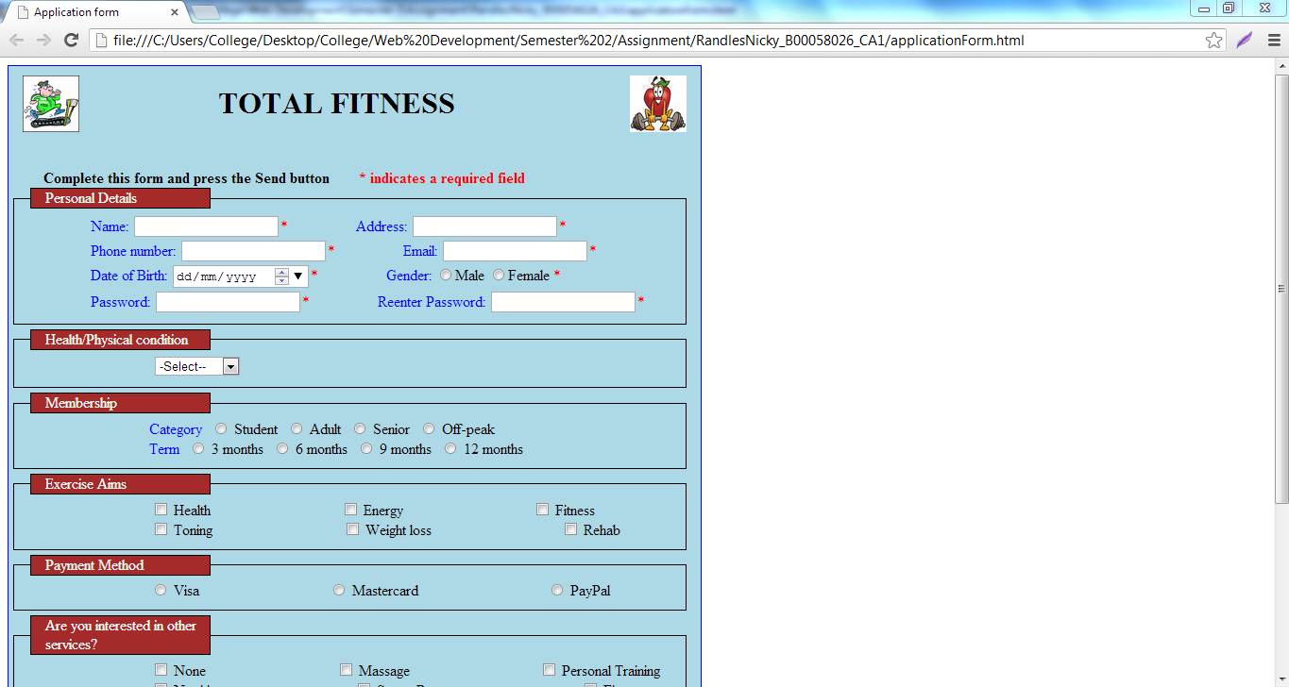

1. **Showing the form with an error message displayed**

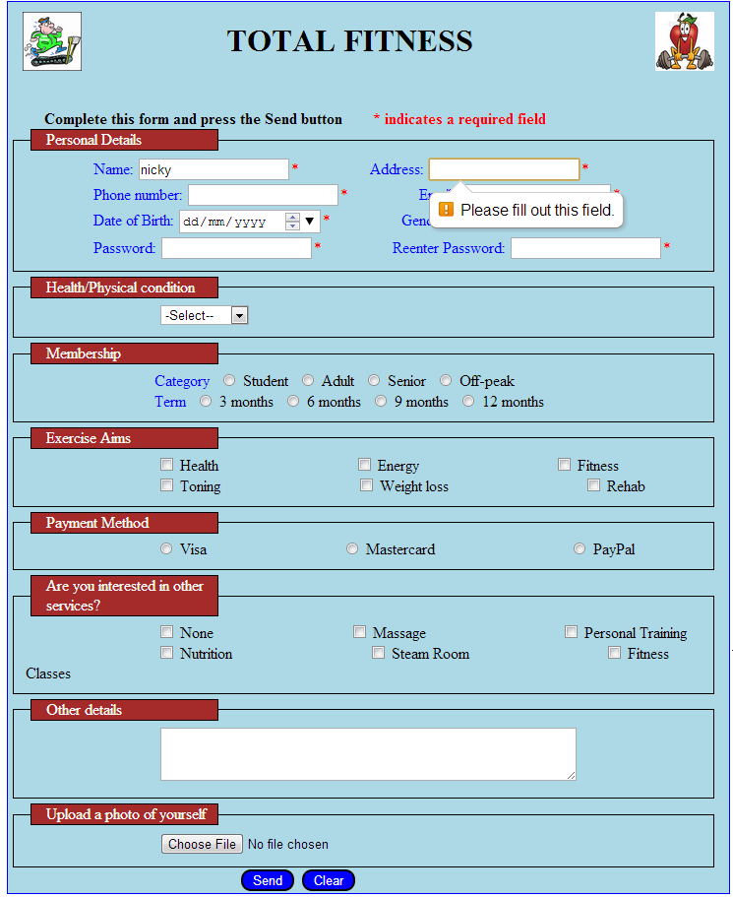

1. **Show the completed form, before it is submitted.**

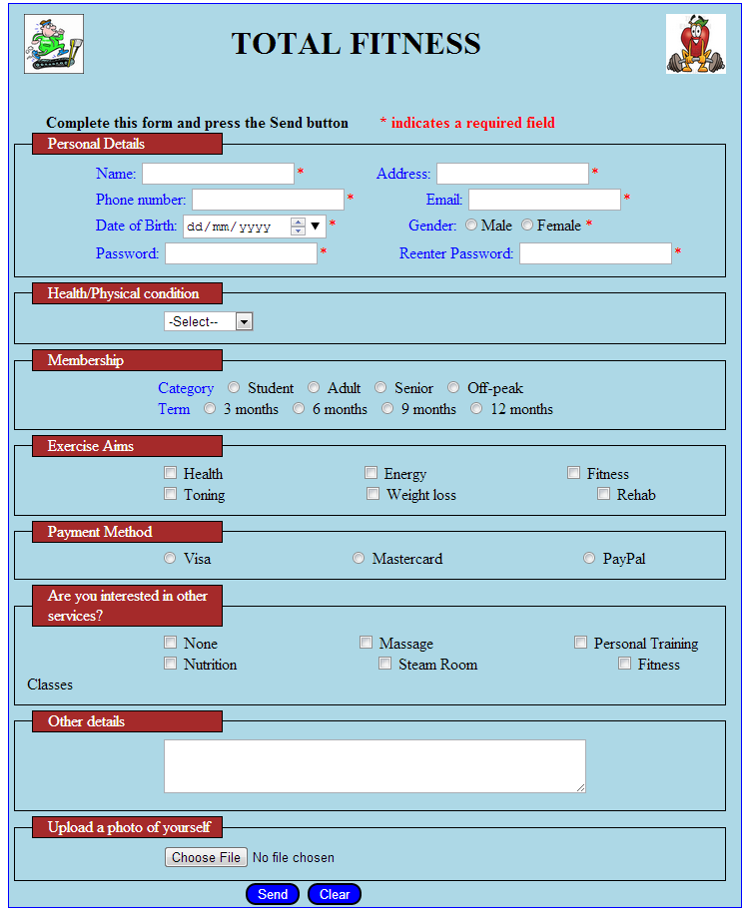

1. **Show the Confirmation page**

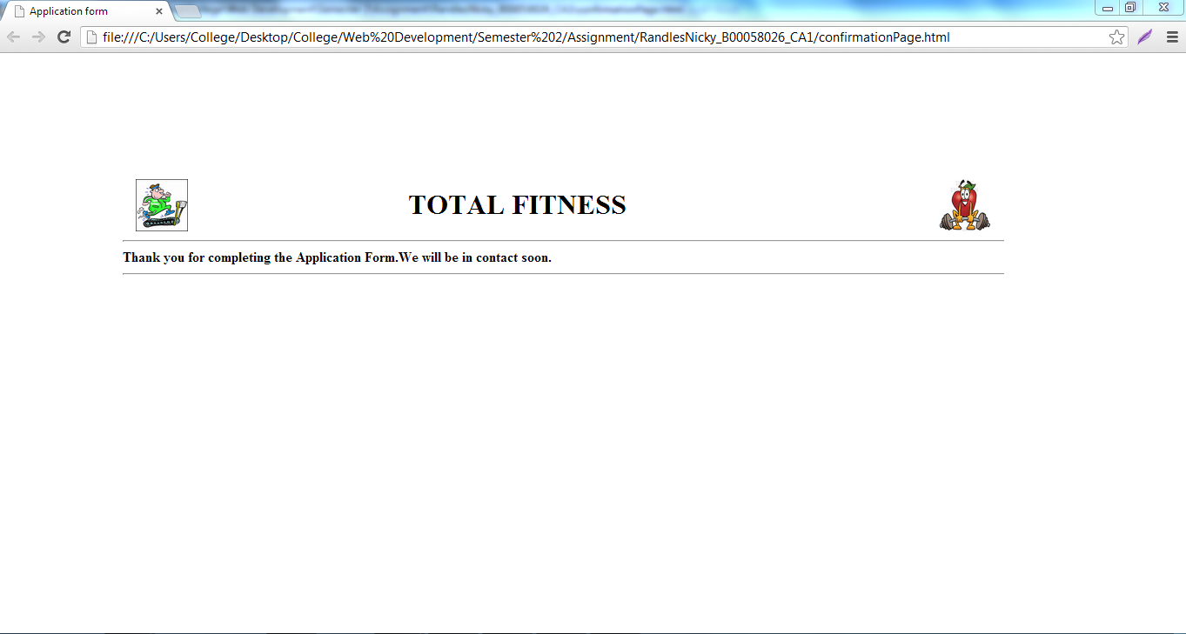

**Html validated**

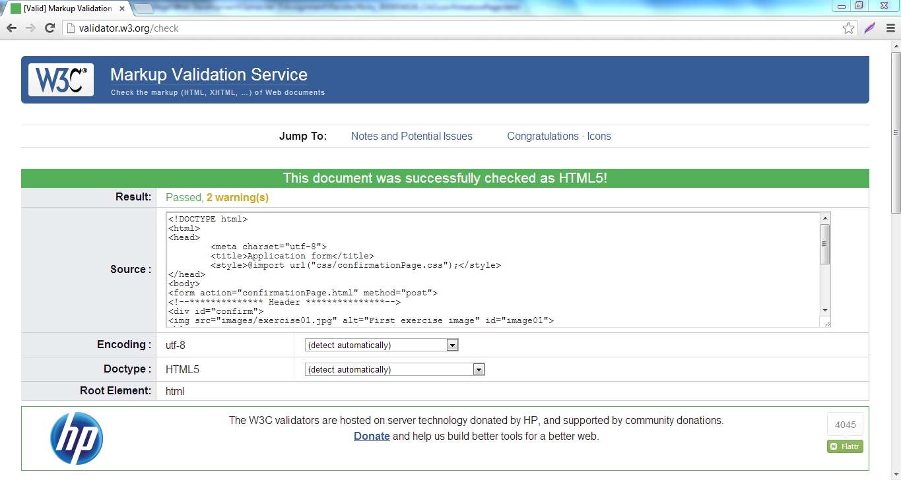

**CSS validated**

